AKSHAYA S(192471061)
EXP 16
Test Different Lists
Aim: To test sorting for different types of lists.
Pseudocode:
- Start.
- Create different lists.
- Sort each list.
- Display the results.
- Stop.
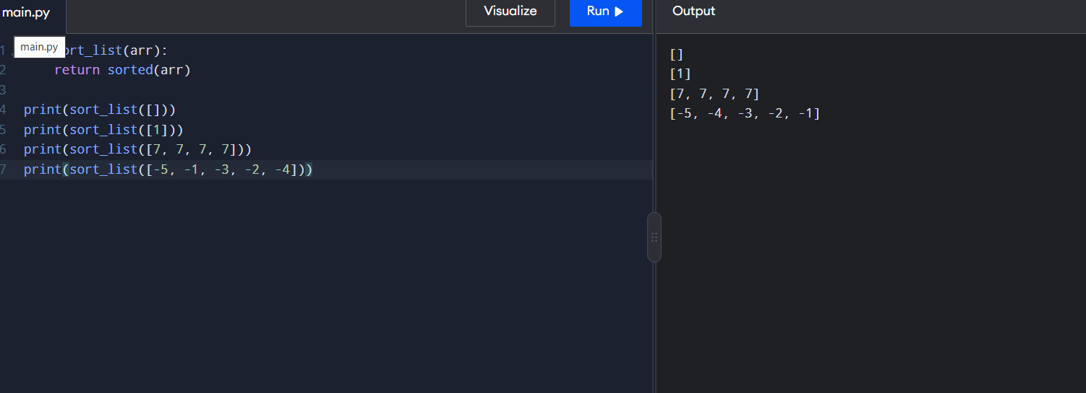
Input: [-3, -1, -2]
Output: [-3, -2, -1]
Result: Sorting works correctly for different lists.

EXP 17
Selection Sort
Aim: To sort elements using selection sort.
Pseudocode:
- Start.
- Find the smallest element.
- Swap it with the current element.
- Repeat until sorted.
- Stop.
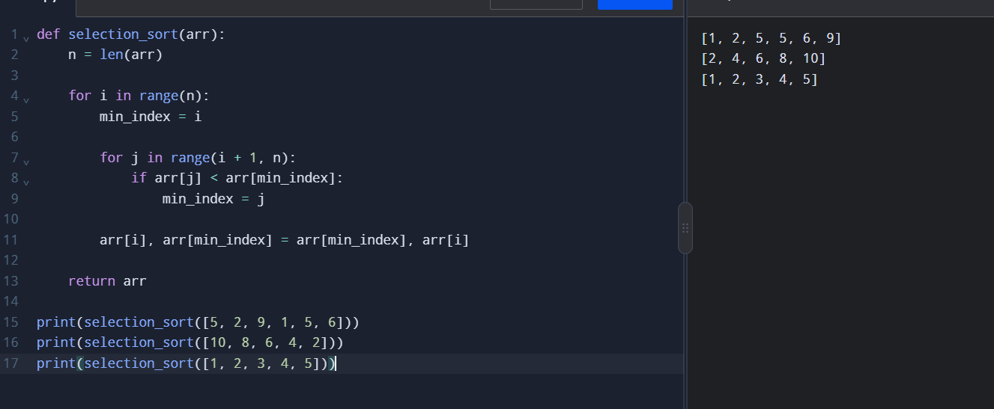
Input: [5, 2, 9, 1, 5, 6]
Output: [1, 2, 5, 5, 6, 9]
Result: The list is sorted successfully.

EXP 19
Optimized Bubble Sort
Aim: To sort a list using optimized bubble sort.
Pseudocode:
- Compare adjacent elements.
- Swap if they are in the wrong order.
- Stop early if no swaps occur.
- Display the sorted list.
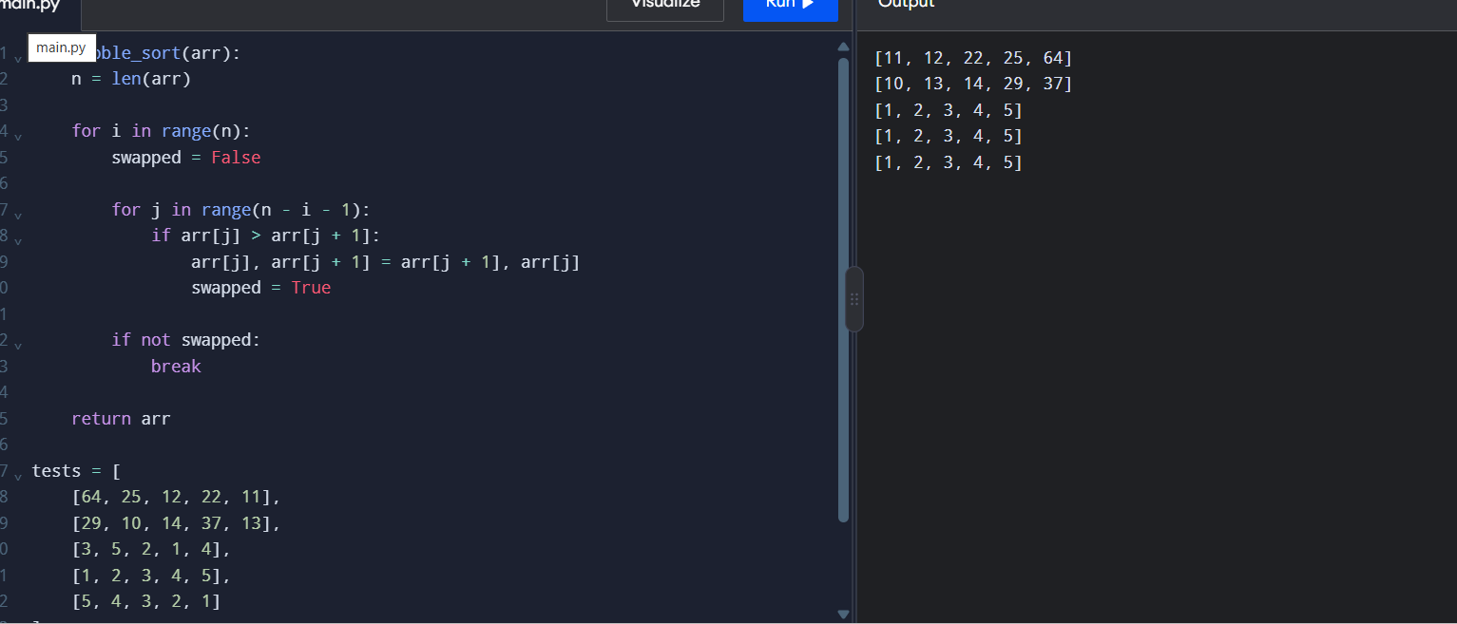

Input: [5, 1, 4, 2, 8]
Output: [1, 2, 4, 5, 8]
Result: The list is sorted efficiently.
EXP 20
Insertion Sort
Aim: To sort elements using insertion sort.
Pseudocode:
- Start from the second element.
- Compare it with previous elements.
- Insert it into the correct position.
- Repeat and display the list.
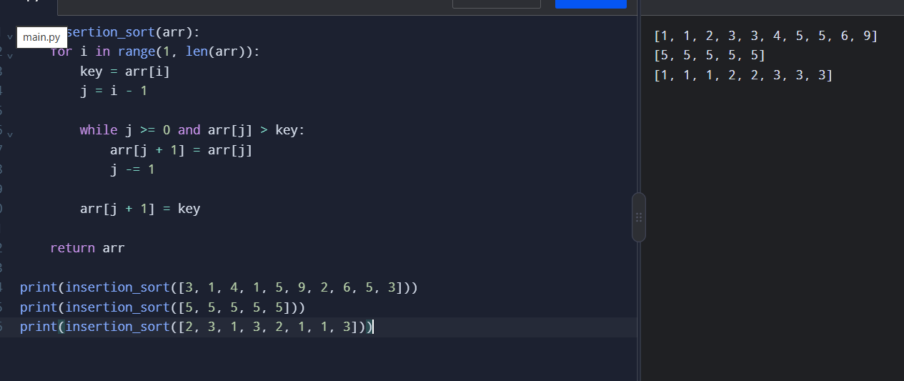
Input: [3, 1, 4, 1, 5]
Output: [1, 1, 3, 4, 5]
Result: The list is sorted successfully, including duplicates.

EXP 21
Kth Missing Positive Number
Aim: To find the kth missing positive number.
Pseudocode:
- Start from 1.
- Check which positive numbers are missing.
- Count missing numbers until k is reached.
- Display the answer.
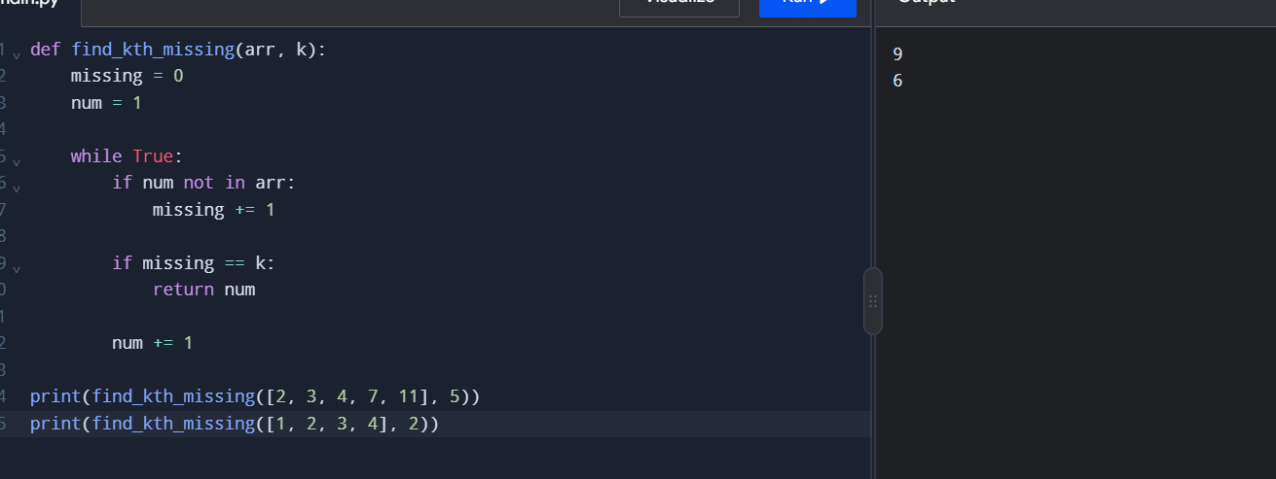
Input: arr = [2, 3, 4, 7, 11], k = 5
Output: 9
Result: The kth missing positive number is found.

EXP 22
Find Peak Element
Aim: To find a peak element using binary search.
Pseudocode:
- Set left and right boundaries.
- Find the middle index.
- Compare middle and next elements.
- Update boundaries.
- Return the peak index.
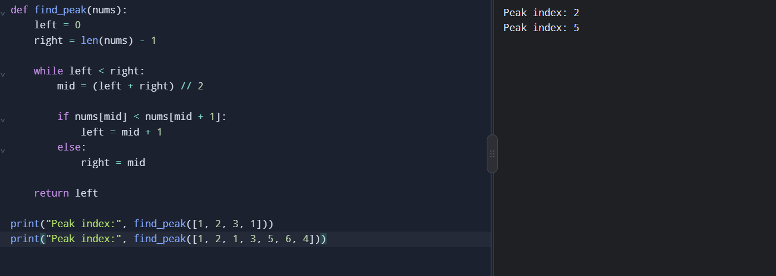

EXP 23:
Find First Substring Occurrence
Aim: To find the first occurrence of a substring.
Pseudocode:
- Start.
- Search for the needle in the haystack.
- Return its index or -1.
- Stop.
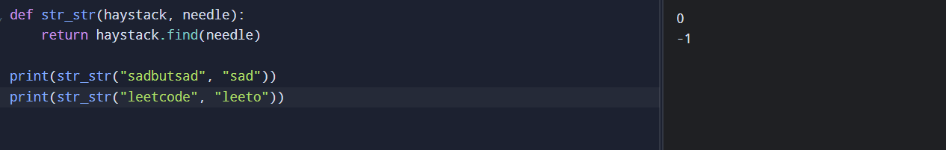
Input: haystack = "sadbutsad", needle = "sad"
Output: 0
Result: The first substring occurrence is found.

EXP 24:
Words That Are Substrings
Aim: To identify words that occur inside other words.
Pseudocode:
- Take a list of words.
- Compare each word with the others.
- Check whether it is a substring.
- Display matching words.
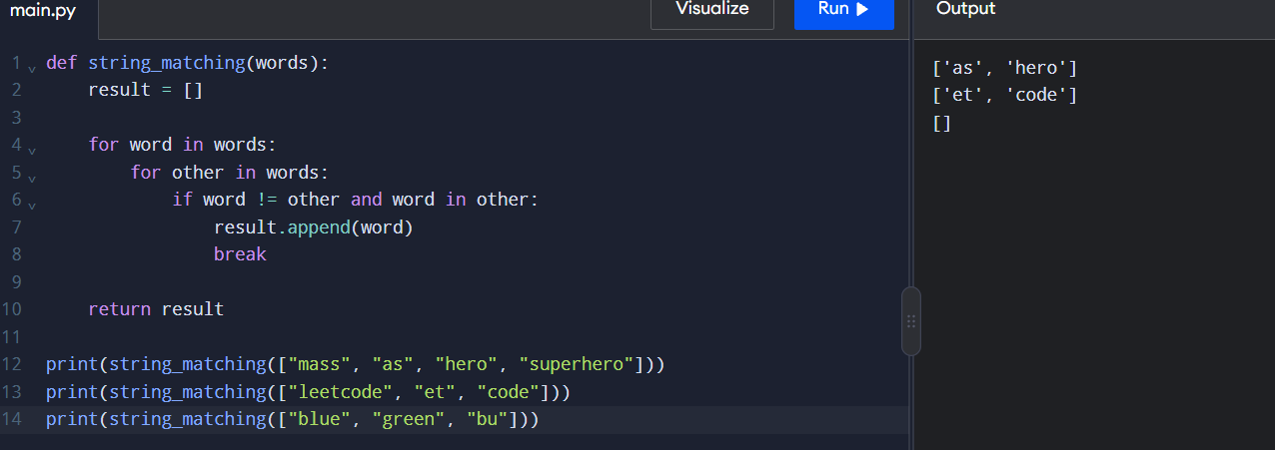
Input: ["mass", "as", "hero", "superhero"]
Output: ["as", "hero"]
Result: Substring words are identified.
EXP 25:
Closest Pair of Points
Aim: To find the closest pair of points.
Pseudocode:
- Take a set of points.
- Calculate distances between every pair.
- Find the minimum distance.
- Display the closest pair.
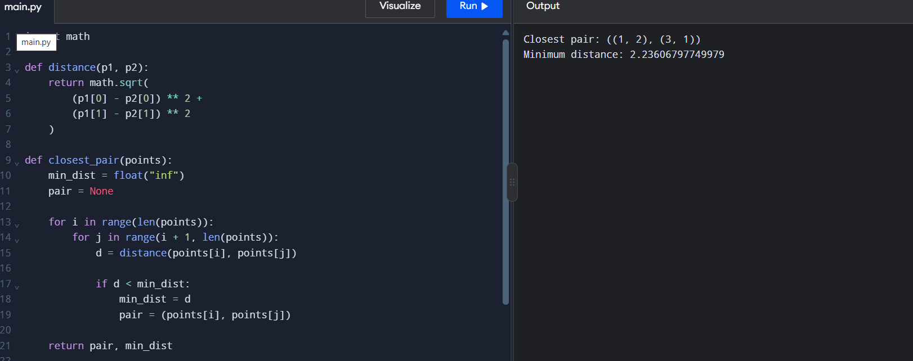
Input: [(1, 2), (4, 5), (7, 8), (3, 1)]
Output: Closest pair: (1, 2) and (3, 1), distance = √5
Result: The closest pair is identified using brute force
EXP 26:
Brute-Force Convex Hull
Aim: To find the convex hull of a set of points.
Pseudocode:
- Take the points.
- Check every pair of points.
- Determine whether all other points lie on one side of the line.
- Display the hull points.
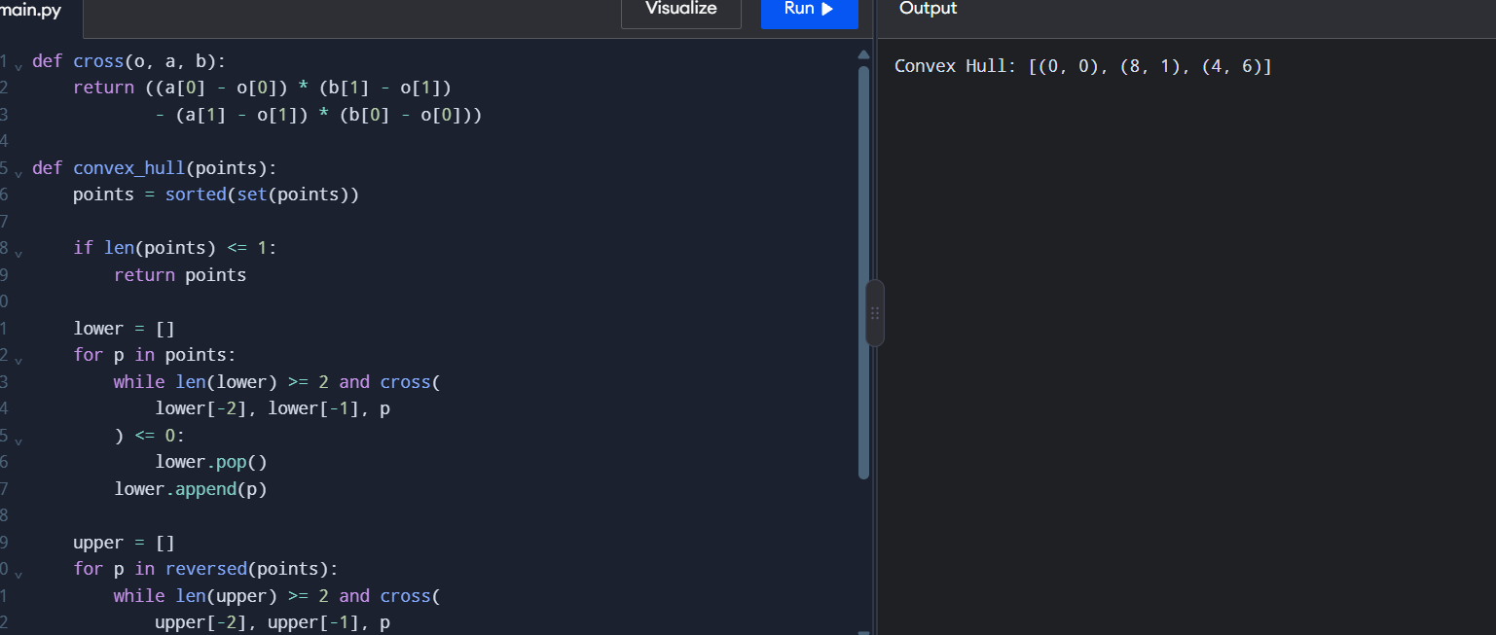
Input: A set of 2D points.
Output: The boundary points forming the convex hull.
Result: The convex hull is identified using brute force.
EXP 27
Convex Hull
Aim: To find the convex hull of 2D points.
Pseudocode:
- Sort the points.
- Build the lower hull.
- Build the upper hull.
- Combine and display the hull.
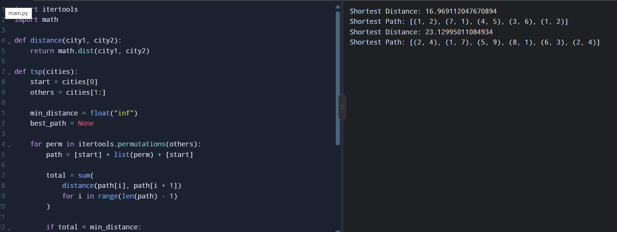
Input: [(1,1), (4,6), (8,1), (0,0), (3,3)]
Output: [(0,0), (8,1), (4,6)]
Result: The outer boundary points are identified.

EXP 28:
Travelling Salesman Problem
Aim: To find the shortest travelling route using exhaustive search.
Pseudocode:
- Fix the starting city.
- Generate all possible routes.
- Calculate each route's total distance.
- Select the shortest route.
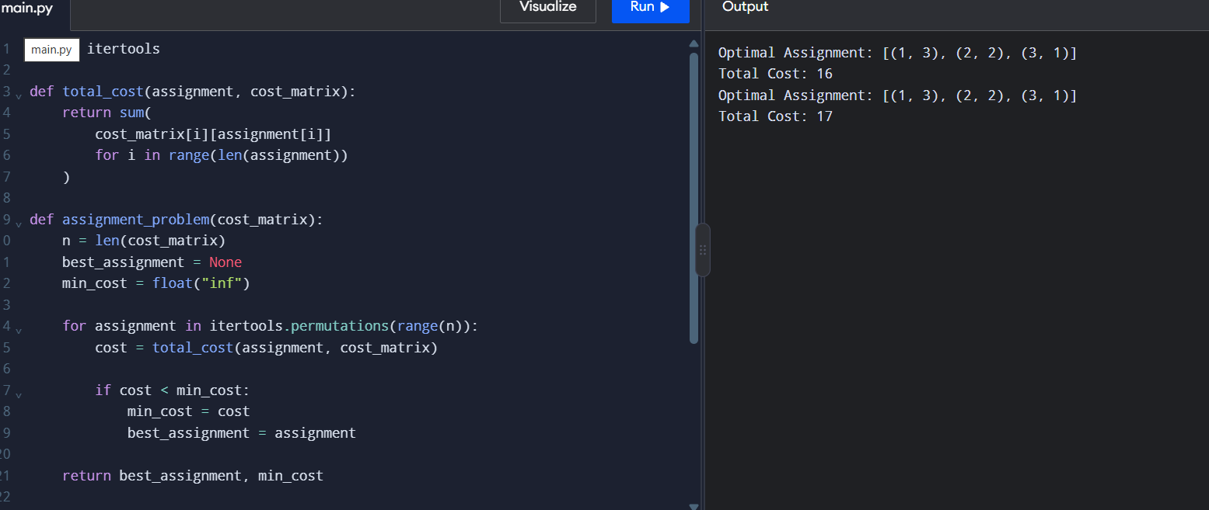
Input: A distance matrix of cities.
Output: Shortest route and minimum distance.
Result: The minimum-cost travelling route is found.

EXP 29:
Aim: To assign tasks to workers with minimum cost.
Pseudocode:
- Take the cost matrix.
- Generate all assignments.
- Calculate each assignment's cost.
- Select the minimum-cost assignment.
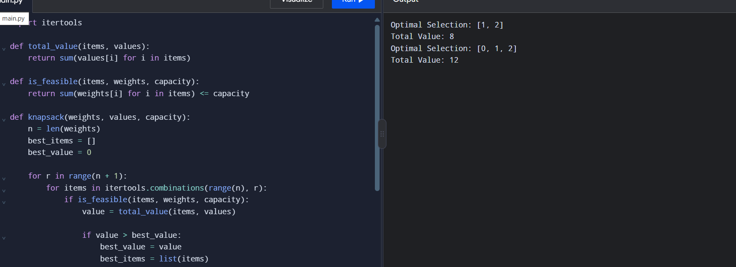
Input: [[3,10,7], [8,5,12], [4,6,9]]
Output: Minimum cost = 19
Result: Tasks are assigned at minimum cost.

Exp 30
0–1 Knapsack Problem
Aim: To maximize the total value within the capacity limit.
Pseudocode:
- Generate all item combinations.
- Calculate total weight and value.
- Reject combinations exceeding capacity.
- Select the combination with maximum value.
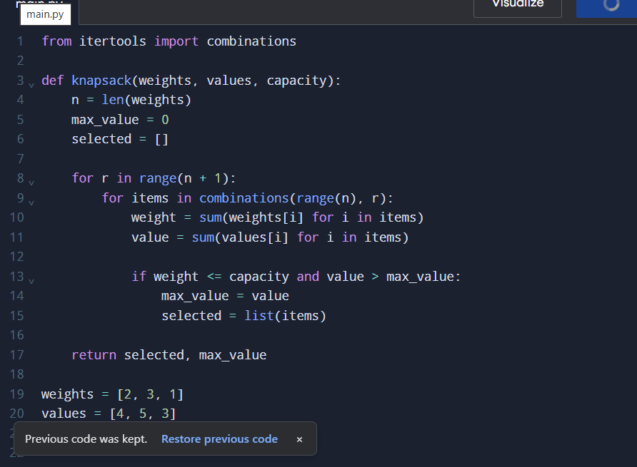
Input: Weights = [2,3,1], Values = [4,5,3], Capacity = 4
Output: Selected items = [0,2], Maximum value = 7
Result: The optimal item selection is found.

